ESD (Employability Skills Development) FA-3

Title:

Call the API through javascript and show it in html. Also implement all CRUD operations Expense Tracker App

**Tools:** Microsoft Word, PhpMyAdmin, Postman

**Screenshot:**

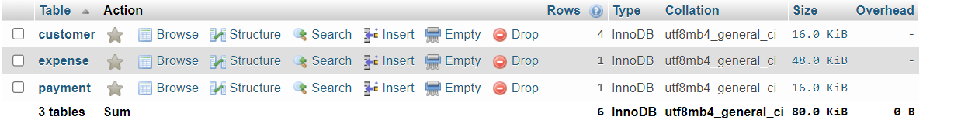 **Database Design**

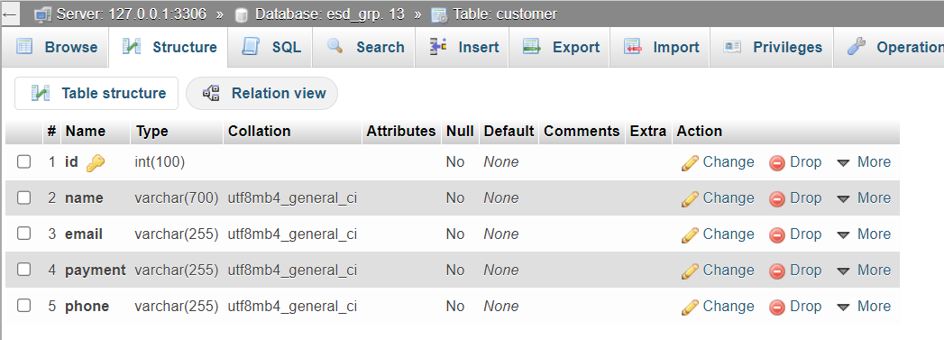 **Structure of Customer Table**

**Table: Customer**

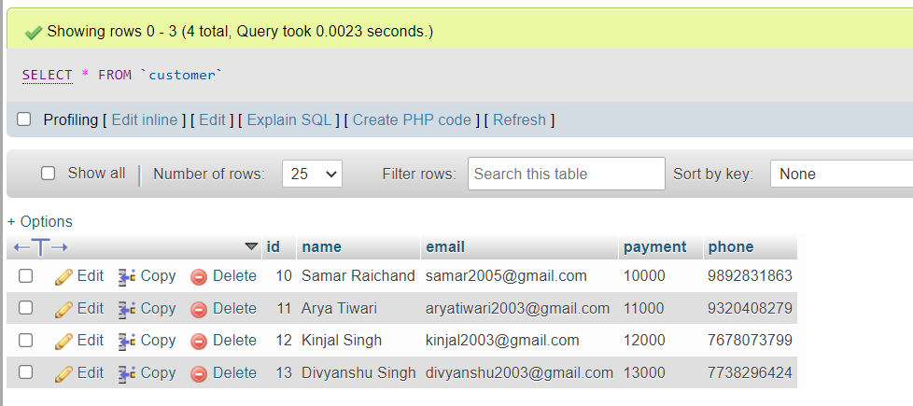

**Project Directory**

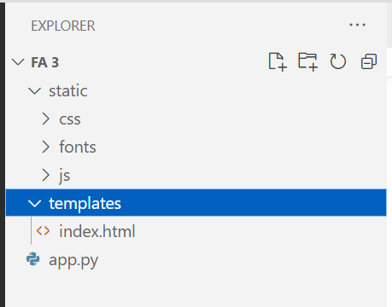

**app.py**

from flask import Flask, render_template, request, url_for, flash

from werkzeug.utils import redirect

from flask_mysqldb import MySQL

app = Flask(__name__)

app.secret_key = ''

app.config['MYSQL_HOST'] = 'localhost'

app.config['MYSQL_USER'] = 'root'

app.config['MYSQL_PASSWORD'] = ''

app.config['MYSQL_DB'] = 'esd_grp. 13'

mysql = MySQL(app)

@app.route('/')

def Index():

    cur = mysql.connection.cursor()

    cur.execute("SELECT * FROM customer")

    data = cur.fetchall()

    cur.close()

    return render_template('index.html', customer=data)

@app.route('/insert', methods = ['POST'])

def insert():

  if request.method == "POST":

        flash("Data Inserted Successfully")

        name = request.form['name']

        email = request.form['email']

        payment = request.form['payment']

        phone = request.form['phone']

        cur = mysql.connection.cursor()

cur.execute("INSERT INTO customer (name, email, payment, phone) VALUES (%s, %s, %s, %s)", (name, email, payment, phone))

        mysql.connection.commit()

return redirect(url_for('Index'))

@app.route('/delete/<string:id_data>', methods = ['GET'])

def delete(id_data):

    flash("Record Has Been Deleted Successfully")

cur = mysql.connection.cursor()

    cur.execute("DELETE FROM customer WHERE id=%s", (id_data,))

    mysql.connection.commit()

    return redirect(url_for('Index'))

@app.route('/update',

methods= ['POST', 'GET'])

def update():

if request.method == 'POST':

        id_data = request.form['id']

        name = request.form['name']

        email = request.form['email']

        payment = request.form['payment']

        phone = request.form['phone']

        cur = mysql.connection.cursor()

cur.execute("""

        UPDATE customer SET name=%s, email=%s, payment=%s, phone=%s

        WHERE id=%s

        """, (name, email, payment, phone, id_data))

        flash("Data Updated Successfully")

        return redirect(url_for('Index'))

if __name__ == "__main__":

    app.run(debug=True)

**MAIN WEB PAGE**

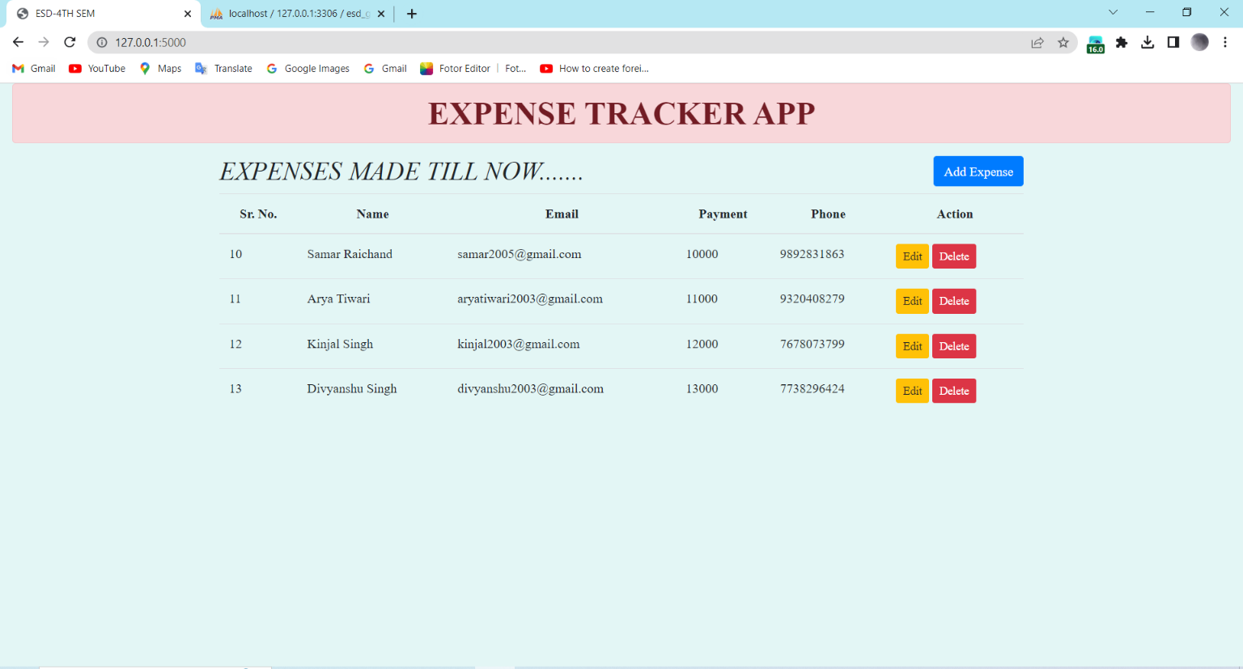

**SHOWING THE EXPENSES MADE BY THE CUSTOMER THROUGH GET METHOD**

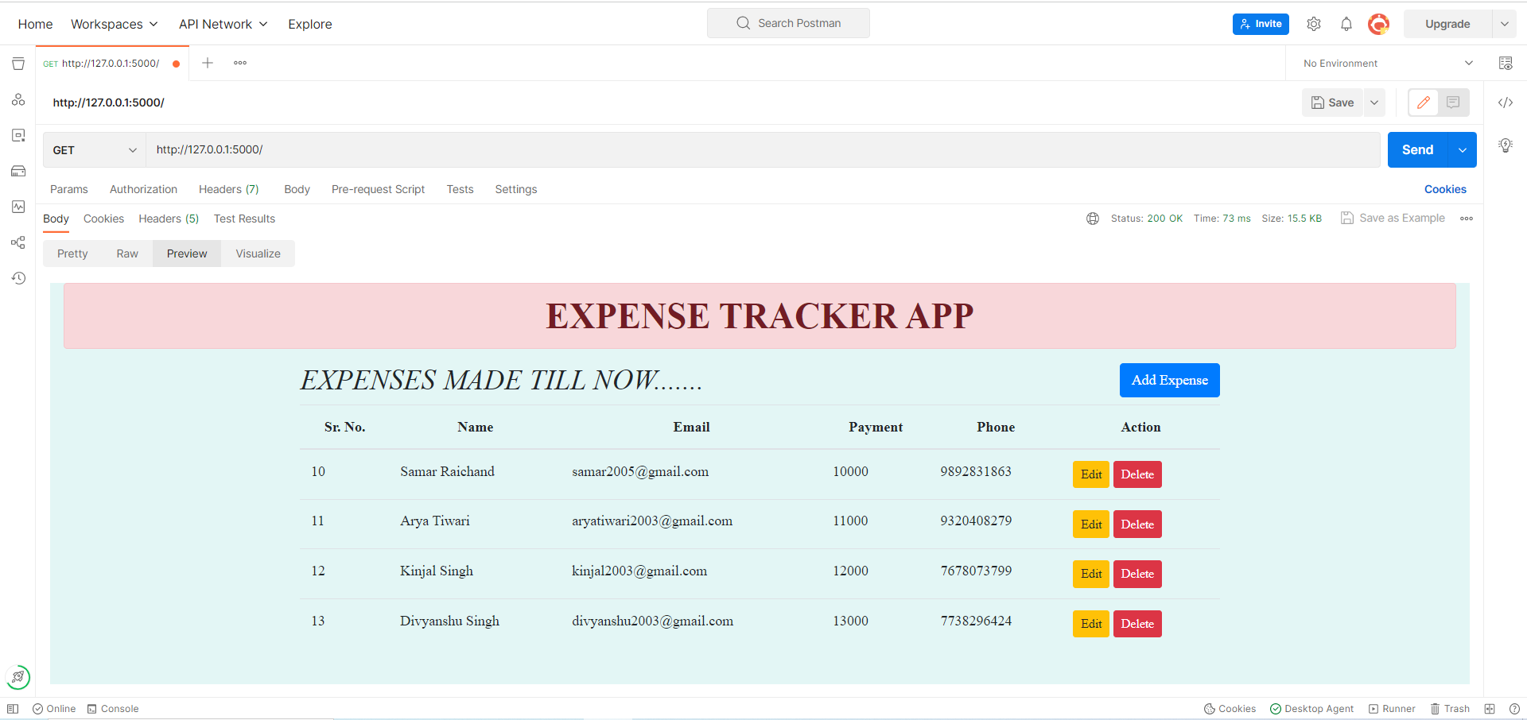

**ADDING THE NEW EXPENSES**

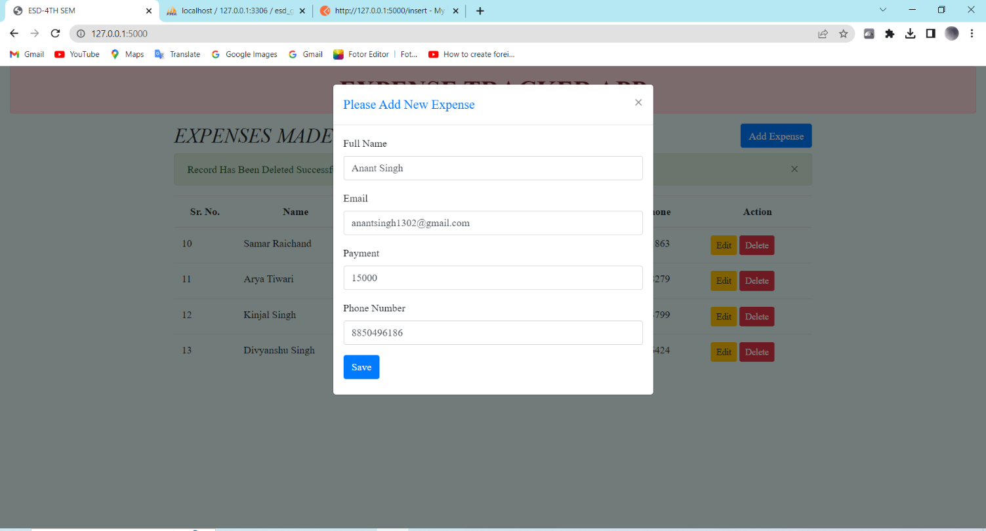

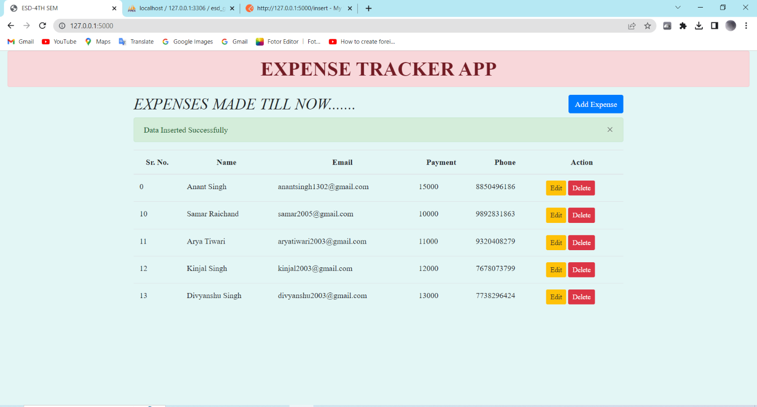

**API_DELETE (DELETE)**

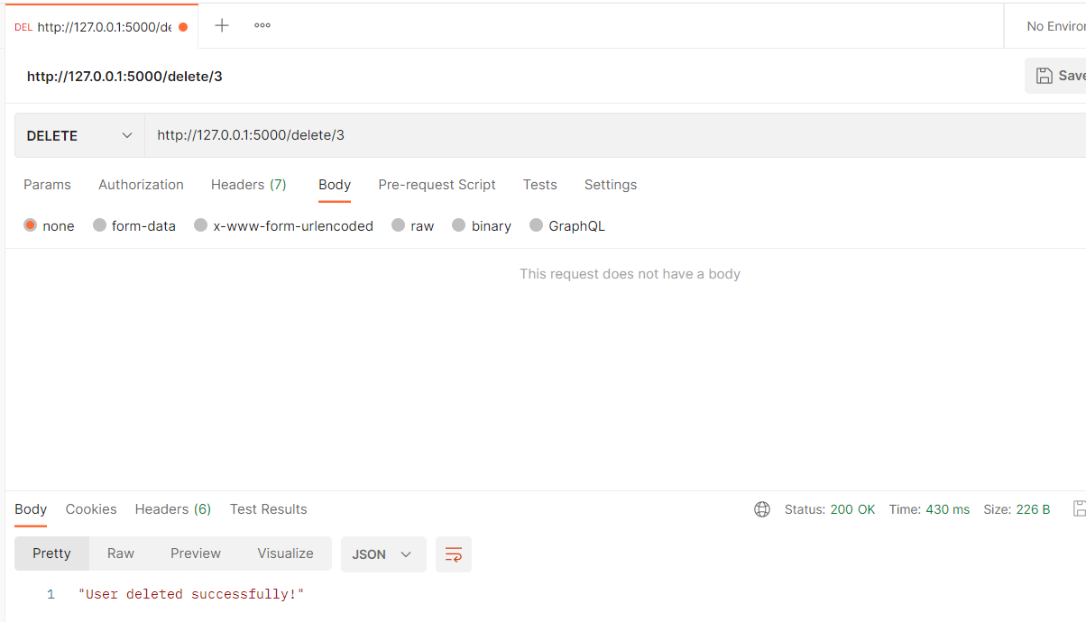

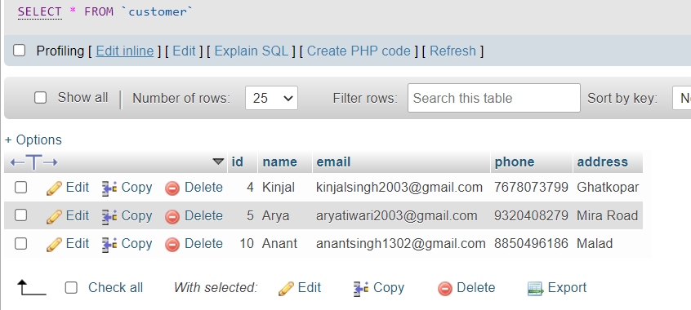

**API_UPDATE (UPDATE)**

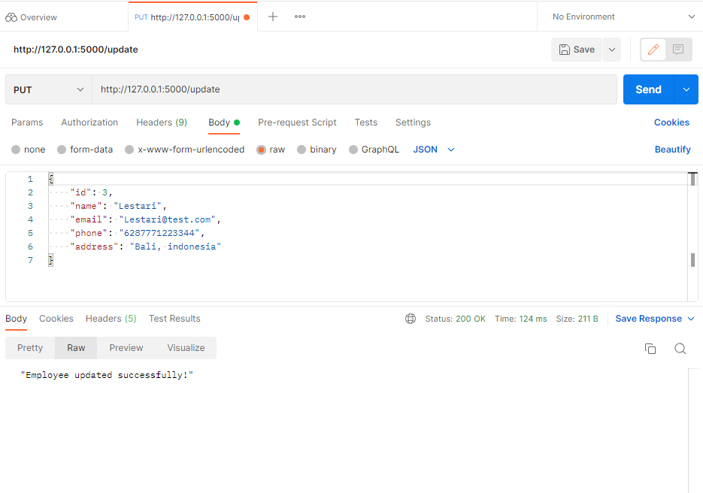

**API_PUT (CREATE)**

